**ABSTRACT**

As the name specifies “HOSTEL MANAGEMENT SYSTEM” is a software developed for managing various activities in the hostel. For the past few years the number of educational institutions are increasing rapidly. Thereby the number of hostels are also increasing for the accommodation of the students studying in this institution. And hence there is a lot of strain on the person who are running the hostel and software’s are not usually used in this context. This particular project deals with the problems on managing a hostel and avoids the problems which occur when carried manually. Identification of the drawbacks of the existing system leads to the designing of computerized system that will be compatible to the existing system with the system Which is more user friendly and more GUI oriented. We can improve the efficiency of the system, thus overcome the drawbacks of the existing system.

· Less human error

· Strength and strain of manual labour can be reduced

· High security

· Data redundancy can be avoided to some extent

· Data consistency

· Easy to handle

· Easy data updating

· Easy record keeping

· Backup data can be easily generated

**1. INTRODUCTION**

**1.1 PROBLEM STATEMENT**

This system is designed in favor of the hostel management which helps them to save the records of the students about their rooms and other things. It helps them from the manual work from which it is very difficult to find the record of the students and the mess bills of the students, and the information of about the those ones who had left the hostel.All the hostels at present are managed manually by the hostel office. The Registration form verification to the different data processing are done manually. Thus there are a lot of repetitions which can be easily avoided. And hence there is a lot of strain on the person who are running the hostel and software’s are not usually used in this context. This particular project deals with the problems on managing a hostel and avoids the problems which occur when carried manually Identification of the drawbacks of the existing system leads to the designing of computerized system that will be compatible to the existing system with the system which is more user friendly . We can improve the efficiency of the system, thus overcome the drawbacks of the existing system. We design this system of the hostel management especially for the college hostel, through this they cannot require so efficient person to handle and calculate the things. This system automatically calculates all the bills and issued the notifications for those students who are against some rules.

1.2.OBJECTIVES OF PROJECT

This software product the hostel management to improve their services for all the students of the hostel. This also reduce the manual work of the persons in admin penal and the bundle of registers that were search when to find the information of a previous student, because through this system you can store the data of those students who had left the hostel . Through this you can check the personal profile of all the current students within few minutes the data base of the system will help you to check a particular one. The system will help you to check the mess bills of every student and the student’s hostel dues. The students of the hostel will be recognized from the ID number allocated at the room rental time. In the last this system will improve the management work in the hostel.

REQUIREMENT ENGINEERING

2. REQUIREMENT ENGINEERING

Systematic requirements analysis is also known as *requirements engineering*.[[3]](http://en.wikipedia.org/wiki/Requirements_analysis#cite_note-2) It is sometimes referred to loosely by names such as *requirements gathering*, *requirements capture*, or requirements specification. The term *requirements analysis* can also be applied specifically to the analysis proper, as opposed to elicitation or documentation of the requirements, for instance. Requirements Engineering can be divided into discrete chronological steps:

* Requirements elicitation,
* Requirements analysis and negotiation,
* Requirements specification,
* System modeling,
* Requirements validation,
* Requirements management.

Requirement engineering according to Laplante (2007) is "a subdiscipline of [systems engineering](http://en.wikipedia.org/wiki/Systems_engineering) and [software engineering](http://en.wikipedia.org/wiki/Software_engineering) that is concerned with determining the goals, functions, and constraints of hardware and software systems. In some [life cycle](http://en.wikipedia.org/wiki/Software_development_life_cycle) models, the requirement engineering process begins with a feasibility study activity, which leads to a feasibility report. If the feasibility study suggests that the product should be developed, then requirement analysis can begin. The requirement engineering provides the appropriate mechanisam for understanding what customer wants.

2.1 FEASIBILITY STUDY  
  
Feasibility study conducted once the problem is clearly understood.Feasibility study is a high level capsule version of the entire system-analysis and design process.The objective is to determine quickly and at the minimum expense how to solve the problem and to determine the problem is solved.The system has been tested for feasibility in the following ways.

Technical feasibility  
Operational feasibility  
Economical feasibility

2.1.1 Technical feasibility

A study of function ,performance and constraints may effect the ability to achieve an acceptable system so ,that necessary function and performance are achieved with in the constraints uncovered during system analysis.The software developed for the automation of Hostel Management System is platform independent and has predefined functions and constraints such as to locate the charges ,validating functions etc.,so the project is technically feasible.  
  
  
2.1.2 Operational feasibility

The purpose of this project is to develop software named Hostel Management which facilitates quick registration process.The activities of the system such as data entry ,information retrieval ,updating and deletion of records from various tables etc are made easy .All the operators of this project are trained in this area.So this project is operational feasible.  
  
2.1.3 Economical feasibility

Economic analysis includes a broad range of concerns that include cost benefit analysis ,long term cooperative income strategies,cost of resources needed for development .In existing they had to maintain a large number of books/registers is a costly affair.This can be avoided by putting the data in the computer format that is cheaper and reliable.Since the cost of resources for development of system satisfies the organization,the software is economically feasible.

2.2 REQUIREMENT ANALYSIS

Requirements Analysis is the process of understanding the customer needs and expectations from a proposed system or application and is a well-defined stage in the Software Development Life Cycle model. Requirements are a description of how a system should behave or a description of system properties or attributes. It can alternatively be a statement of ‘what’ an application is expected to do.Given the multiple levels of interaction between users, business processes and devices in global corporations today, there are simultaneous and complex requirements from a single application, from various levels within an organization and outside it as well.The Software Requirements Analysis Process covers the complex task of eliciting and documenting the requirements of all these users, modeling and analyzing these requirements and documenting them as a basis for system design. Software Requirements Analysis and Documentation Processes are critical to software project success. Requirements Engineering is an emerging field which deals with the systematic handling of requirements.

2.2.1.EXISTING SYSTEM

Analysis begins when a user or manager begins a study of the program using existing system. During analysis, data collected on the various files, decision points and transactions handled by the present system. The commonly used tools in the system are Data Flow Diagram, interviews, etc. training, experience and common sense are required for collection of relevant information needed to develop the system. The existing hostel management system most of the operation like checking out of rooms, allocating rooms ,calculating hostel bill , vacating rooms, management of notice board details etc done manually which includes a lot of human error, more data redundancy and wastage of time.

2.2.2 PROBLEM RECOGNITION

For the past few years the number of educational institutions is increasing rapidly. Thereby the number of hostels is also increasing for the accommodation of the students studying in this institution. And hence there is a lot of strain on the person who are running the hostel and software’s are not usually used in this context. If we are doing it manually more human error , more strength and strain of manual labour needed, Repetition of the same procedures, low security, Data redundancy, difficult to handle, difficult to update data, record keeping is difficult , Backup data can be easily generated will occur.

2.2.3 PROBLEM EVALUVATION AND SYNTHESIS

The project hostel management deals with the problems on managing a hostel and avoids the problems which occur when carried manually. Identification of the drawbacks of the existing system leads to the designing of computerized system that will be compatible to the existing system with the system which is more user friendly. We can improve the efficiency of the system, thus overcome the following drawbacks of the existing system.

2.3 PROPOSED SYSTEM

The drawback of the existing system is that it is very difficult to retrieve data from records. It is difficult to handle the whole system manually and it is less accurate and to keep the data in records for future reference because it may get destroyed .  Moreover it is very difficult to retrieve data. Redundancy of data may occur and this may lead to the inconsistency. The manual system is so time-consuming. The proposed system is very easy to operate. Speed and accuracy are the main advantages of proposed system. There is no redundancy of data. The data are stored in the computer secondary memories like hard disk, etc. it can be easily receive and used at any time. The proposed system will easily handle all the data and the work done by the existing systems. The proposed systems eliminate the drawbacks of the existing system to a great extent and it provides tight security to data.

REQUIREMENT AND SPECIFICATION

* 1. SYSTEM REQUIREMENT

This project mainly aims to deal the operations of college hostel …

It consist of 2 modules.

* User module
* Administrator module

USER MODULE CONSIST OF

* User login
* View notice board

ADMINSTRATOR MODULE CONSIST OF

* Admin login
* Registration
* Allocation
* Vocate
* Hostelbill

**3.1.1 User Panel**

**3.1.1.1 User Login**

1. It allows the different users to access the registration forms.
2. User can view the details of notice boards.

**3.1.1.1.1 Notice Board**

Any change in the Hostel fee, mess fee will be shown in this. It can be also used for different notifications.

**3.1.1.2 Admin Panel**

**3.1.1.2.1 Administrator Login**

**3.2.1.1 Home**

The Administrator can :

1. Allot students to the hostel.

2. Vacate the students form the hostel.

3. Control the status of the fee payement.

4. Edit the details of the students & modify the student records.

**3.2.1.2 Registration Form**

**3.2.1.3 Allocating the rooms**

**3.2.1.4Vacating the rooms**

As the student’s course is over they will vacate their rooms. So it is required for the administrator to remove their records from the database tables. This section includes the option for the room vacation and the deletion of the particular record from the database

* 1. **REQUIREMENTS**

**3.2.1 Software Configuration**

**Front end : C#.NET**

**Backend : Microsoft SQL Server 2005**

**Operating**

**System : Windows XP**

**Language : C#**

**Frame work : Visual studio 2005 framework 2.0**

**3.2.2 Hardware Configuration**

**Processor : Pentium III,1.13GHz**

**RAM :128 Mb SD RAM**

**Monitor : SVGA, samtron 56v**

**Keyboard : Samsung Keyboard 105 keys**

**Mouse : Logitech 3-Button**

**CD-ROM : Samsung 52X**

**Floppy Drive : 1.44Mb[3 ½] sony**

**Hard Drive : 40GB HDD**

**Mother Board : Pentium 810**

**DESIGN**

**SYSTEM DESIGN**

**4.1 Input Design**

The system design is divided in to two portions. The Administrator section and the User(student’s) section.

**4.1.1 Administrator**

1. The Administrator can allot students to the hostel.

2.He can vacate the students form the hostel.

3.He can control the status of the fee payement.

4.He can edit the details of the students.He can change their rooms, edit and delete the student records.

A process of converting user originated inputs to a computer-based format. Input design is an important part of development process since inaccurate input data are the most common cause of errors in data processing. Erroneous entries can be controlled by input design. It consists of developing specifications and procedures for entering data into a system and must be in simple format**.** The goal of input data design is to make data entrybas easy, logical and free from errors as possible. In input data design, we design the source document that capture the data and then select the media used to enter them into the computer. There are two major approaches for entering data in to the computer. They are

· Menus.

· Dialog Boxes.

**Menus**

A menu is a selection list that simplifies computer data access or entry. Instead of remembering what to enter, the user chooses from a list of options. A menu limits a user choice of response but reduce the chances for error in data entry.

**Dialog Box**

Dialog boxes are windows and these windows are mainly popup, which appear in response to certain conditions that occur when a program is run. It allows the display of bitmaps and pictures. It can have various controls like buttons, text boxes, list boxes and combo boxes. Using these controls we can make a ‘dialog’ with the program.

**4.2 Output Design**

Designing computer output should proceed in an organized, well throughout manner; the right output element is designed so that people will find the system whether or executed. When we design an output we must identify the specific output that is needed to meet the system. The usefulness of the new system is evaluated on the basis of their output.Once the output requirements are determined, the system designer can decide what to include in the system and how to structure it so that the require output can be produced. For the proposed software, it is necessary that the output reports be compatible in format with the existing reports. The output must be concerned to the overall performance and the system’s working, as it should. It consists of developing specifications and procedures for data preparation, those steps necessary to put the inputs and the desired output, ie maximum user friendly. Proper messages and appropriate directions can control errors committed by users. The output design is the key to the success of any system. Output is the key between the user and the sensor. The output must be concerned to the system’s working, as it should. Output design consists of displaying specifications and procedures as data presentation. User never left with the confusion as to what is happening without appropriate error and acknowledges message being received.

**4.3 Database Design**

The data in the system has to be stored and retrieved from database. Designing the database is part of system design. Data elements and data structures to be stored have been identified at analysis stage. They are structured and put together to design the data storage and retrieval system. A database is a collection of interrelated data stored with minimum redundancy to serve many users quickly and efficiently. The general objective is to make database access easy, quick, inexpensive and flexible for the user. Relationships are established between the data items and unnecessary data items are removed. Normalization is done to get an internal consistency of data and to have minimum redundancy and maximum stability. This ensures minimizing data storage required, minimizing chances of data inconsistencies and optimizing for updates.

4.4 ARCHITECTURAL DESIGN

Architectural design represents the data structure and program components that are required to build the computer based system. It consider the structures and properties Of the components that constitute the system and relationship that exist between all architectural components of the system.

**4.5 Process Design**

Process design plays an important role in project development. In order to understand the working procedure, process design is necessary. Data Flow Diagram is the tool used for process design. Data Flow Diagram is the logical representation of the data flow of the project. The DFD is drawn using various symbols. It has a source and a destination. The process is represented using circlesand source and destination are represented using squares. The data flow is represented using arrows. One reader can easily get the idea about the project through Data Flow Diagram.

**4.6 IMPLEMENTATION DESIGN**

**IMPLEMENTATION**

**SYSTEM TESTING**

System testing is the stage of implementation, which is aimed at ensuring that the system works accurately and efficiently before live operation commences. Testing is the process of executing the program with the intent of finding errors and missing operations and also a complete verification to determine whether the objectives are met and the user requirements are satisfied. The ultimate aim is quality assurance. Tests are carried out and the results are compared with the expected document. In the case of erroneous results, debugging is done. Using detailed testing strategies a test plan is carried out on each module. The various tests performed in “**Network Backup System**” are unit testing, integration testing and user acceptance testing.

**5.1 Unit Testing**

The software units in a system are modules and routines that are assembled and integrated to perform a specific function. Unit testing focuses first on modules, independently of one another, to locate errors. This enables, to detect errors in coding and logic that are contained within each module. This testing includes entering data and ascertaining if the value matches to the type and size supported by java. The various controls are tested to ensure that each performs its action as required.

**5.2 Integration Testing**

Data can be lost across any interface, one module can have an adverse effect on another, sub functions when combined, may not produce the desired major functions. Integration testing is a systematic testing to discover errors associated within the interface. The objective is to take unit tested modules and build a program structure. All the modules are combined and tested as a whole. Here the Server module and Client module options are integrated and tested. This testing provides the assurance that the application is well integrated functional unit with smooth transition of data.

**5.3 User Acceptance Testing**

User acceptance of a system is the key factor for the success of any system. The system under consideration is tested for user acceptance by constantly keeping in touch with the system users at time of developing and making changes whenever required.

**IMPLEMENTATION**

Implementation is the stage in the project where the theoretical design is turned into a working system and is giving confidence on the new system for the users that it will work efficiently and effectively. It involves careful planning, investigation of the current system and its constraints on implementation, design of methods to achieve the change over, an evaluation of change over methods. Apart from planning major task of preparing the implementation are education and training of users. The implementation process begins with preparing a plan for the implementation of the system. According to this plan, the activities are to be carried out, discussions made regarding the equipment and resources and the additional equipment has to be acquired to implement the new system. In network backup system no additional resources are needed. Implementation is the final and the most important phase. The most critical stage in achieving a successful new system is giving the users confidence that the new system will work and be effective. The system can be implemented only after thorough testing is done and if it is found to be working according to the specification. This method also offers the greatest security since the old system can take over if the errors are found or inability to handle certain type of transactions while using the new system.

**7.1 User Training**

After the system is implemented successfully, training of the user is one of the most important subtasks of the developer. For this purpose user manuals are prepared and handled over to the user to operate the developed system. Thus the users are trained to operate the developed system. Both the hardware and software securities are made to run the developed systems successfully in future. In order to put new application system into use, the following activities were taken care of:

· Preparation of user and system documentation

. Conducting user training with demo and hands on

· Test run for some period to ensure smooth switching over the system

The users are trained to use the newly developed functions. User manuals describing the procedures for using the functions listed on menu are circulated to all the users. It is confirmed that the system is implemented up to users need and expectations.

**7.2 Security and Maintenance**

Maintenance involves the software industry captive, typing up system resources .It means restoring something to its original condition. Maintenance follows

conversion to the extend that changes are necessary to maintain satisfactory operations relative to changes in the user’s environment. Maintenance often includes minor enhancements or corrections to problems that surface in the system’s operation. Maintenance is also done based on fixing the problems reported, changing the interface with other software or hardware enhancing the software.Any system developed should be secured and protected against possible hazards. Security measures are provided to prevent unauthorized access of the database at various levels. An uninterrupted power supply should be so that the power failure or voltage fluctuations will not erase the data in the files. Password protection and simple procedures to prevent the unauthorized access are provided to the users .The system allows the user to enter the system only through proper user name and password.

*TABLES*

*1.LOGIN*

|  |  |
| --- | --- |
| ***FIELD NAME*** | ***DATA TYPE*** |
| *Username* | *Varchar* |
| *Password* | *Varchar* |

*2.STUDENTDETAILS*

|  |  |
| --- | --- |
| ***FIELD NAME*** | *DATA TYPE* |
| *id* | *Int* |
| *name* | *Varchar* |
| *Pname* | *Varchar* |
| *address* | *Varchar* |
| *age* | *Int* |
| *dob* | *Date time* |
| *lname* | *Varchar* |
| *lrelation* | *Varchar* |
| *ladderss* | *Varchar* |
| *occupation* | *Varchar* |
| *doj* | *Date time* |
| *Resno* | *Int* |
| *Mobno* | *Int* |
| *sem* | *Varchar* |
| *branch* | *Varchar* |
| *batch* | *Int* |
| *Roomno* | *Int* |
| *status* | *Varchar* |

*3.ROOMDETAILS*

|  |  |
| --- | --- |
| *FIELD NAME* | *DATA TYPE* |
| *id* | *Int* |
| *roomno* | *Iny* |
| *Noofstudent* | *Int* |
| *Vacancy* | *Int* |
| *Roomrent* | *Int* |

*4.MESSDETAILS*

|  |  |
| --- | --- |
| *FIELD NAME* | *DATA TYPE* |
| *id* | *Int* |
| *food* | *Varchar* |
| *vegrate* | *Int* |
| *Nonvagrate* | *Int* |
| *Amount* | *Int* |

*5.ATTENDENCE DETAILS*

|  |  |
| --- | --- |
| *FIELD NAME* | *DATA TYPE* |
| *id* | *Int* |
| *name* | *Varchar* |
| *thumb* | *Int* |

*6.VOCATE*

|  |  |
| --- | --- |
| *FIELD NAME* | *DATA TYPE* |
| *id* | *Int* |
| *name* | *Varchar* |
| *branch* | *Varchar* |
| *sem* | *Varchar* |
| *batch* | *Decimal* |
| *roomno* | *Int* |
| *status* | *Varchar* |

*7.ACCOUNT DETAILS*

|  |  |
| --- | --- |
| *FIELD NAME* | *DATA TYPE* |
| *Id* | *Int* |
| *Cautionfee* | *Decimal* |
| *Registerfee* | *Decimal* |
| *Room rent* | *Decimal* |
| *Mess bill* | *Decimal* |
| *Fine* | *Decimal* |
| *Totalfee* | *Decimal* |
| *Refund* | *Decimal* |
| *Paid or not paid* | *Varchar* |

LEVEL 0

LEVEL 1

LEVEL 2

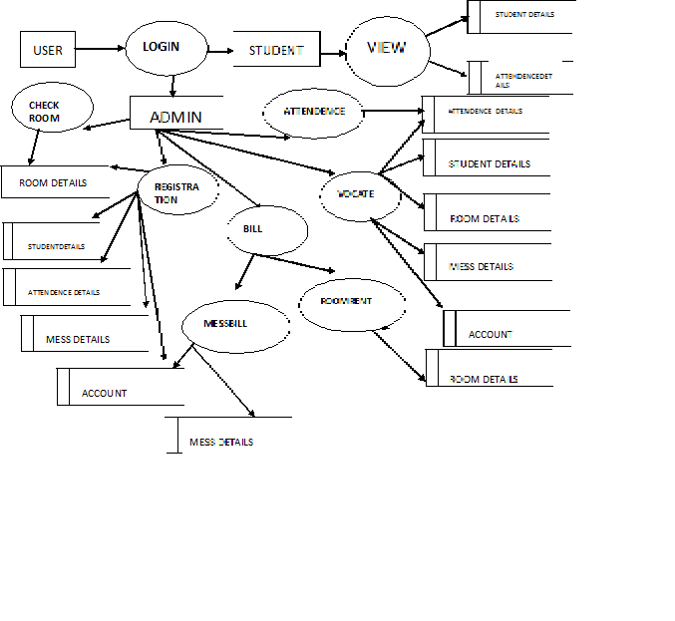

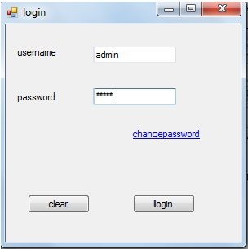

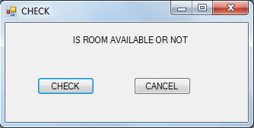

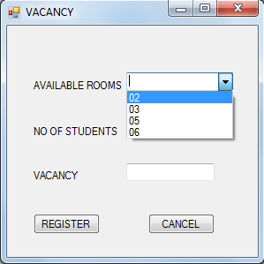

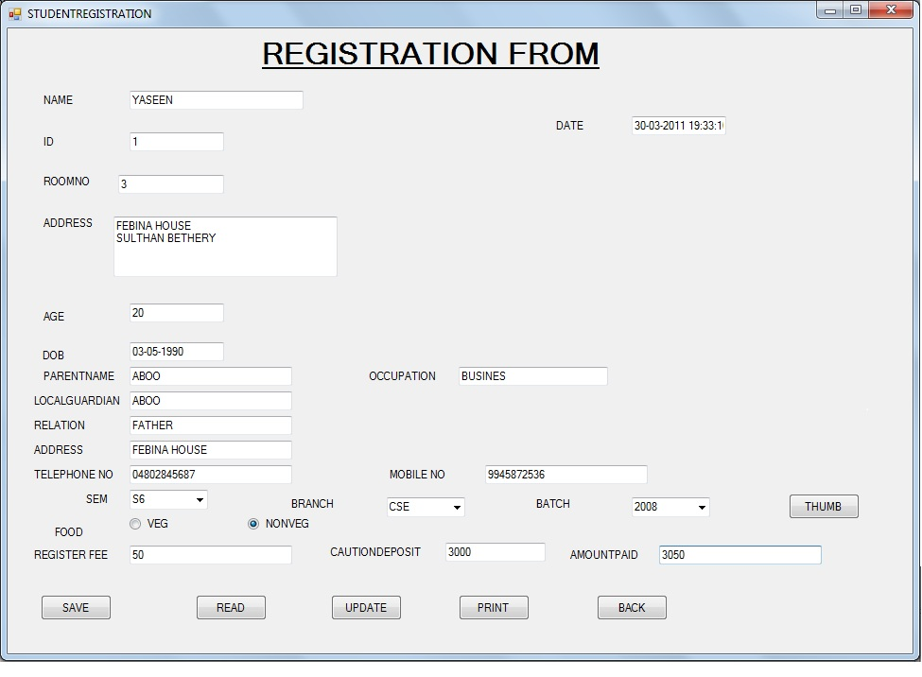

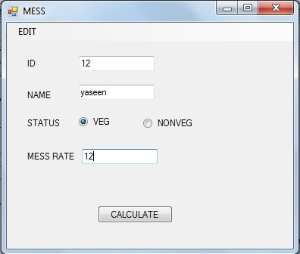

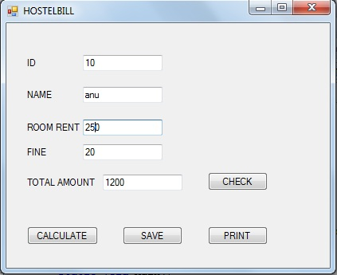

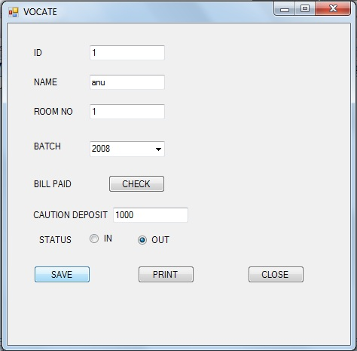

CONCLUTION

* Identification of the drawbacks of the existing system leads to the designing of computerized system that will be compatible to the existing system with the system Which is more user friendly……….
* We can improve the efficiency of the system, thus overcome the drawbacks of the existing system